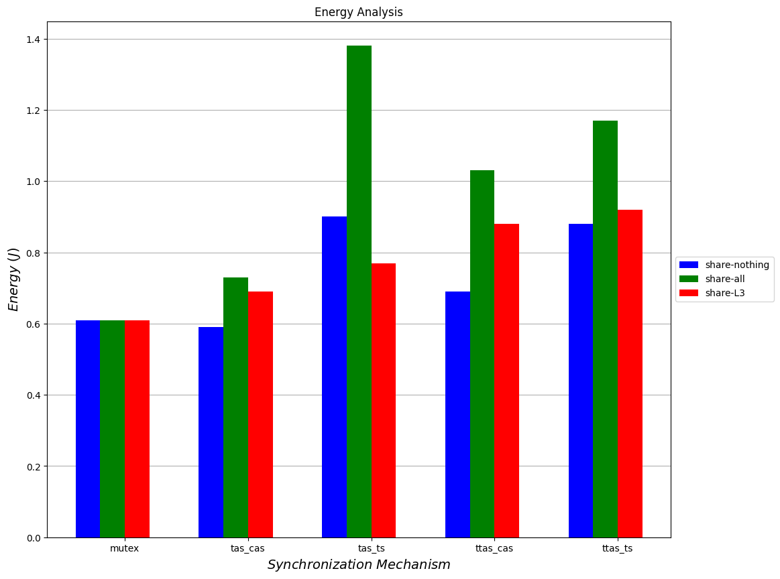

Energy Analysis

*Energy ( )*

share-nothing share-all share-L3

**mutex**

**tas_cas**

**ttas_cas**

ttas_ts

*tas_ts Synchronization Mechanism*